POLICY BRIEF

Nainital Through the Tourist Lens: Experiences, Challenges and Policy

Submission under the course: Field Work II
_______________________________________________
Submitted by: Group 3
Aditi Ranjan (M2024BSASS003) – Key Issues
Jeel Markana (M2024BSASS013) – Evidence from the Field
Krisha Mitra (M2024BSASS015) – Executive Summary, Background and Context
Ravi Pratap Singh (M2024BSASS022) – Policy Recommendations, Conclusion

21st August 2026

Nainital Through the Tourist Lens: Experiences, Challenges and Policy

Executive Summary
Uttarakhand is a state known for its beautiful landscapes and green scenery. Nainital is a popular tourist spot famous for its natural beauty, nice weather, lake, and fun activities. Many visitors come to this town from different parts of India. Nainital is built around Naini Lake and has limited space, which makes managing tourism a challenge. The town sees a large number of tourists, especially during peak seasons, putting pressure on roads, public facilities, and the environment (Bhakuni et. al., 2017). Issues such as traffic, limited parking, public toilets, and waste management can affect both tourists and local residents.
This policy brief looks at tourists' experiences in Nainital using primary data collected during the Urban Immersion conducted from June 21 to July 2. The analysis uses two open-ended questions from the tourist survey: their best experience and the challenges they faced. These responses are grouped into common themes to understand the main issues faced by tourists. The analysis also looks at age, state of residence, purpose of visit, and mode of transport to identify patterns among different groups of visitors.
The main issues explored in the brief are parking and mobility, public amenities, and waste and cleanliness. For instance, tourists travelling by private vehicles reported difficulties in finding parking in Nainital. Concerns about public toilets and cleanliness were also reported by visitors. At the same time, tourists spoke positively about Nainital's natural beauty and recreational activities. This concern is also seen at the state level. Research on tourism in Uttarakhand has linked rapid tourism growth and large visitor inflows to unplanned development and pressure on the region's fragile ecology (Chandra & Kumar, 2021).
The findings are compared with tourism policies, mainly focusing on solid waste management and other local tourism issues. The analysis looks at patterns in the tourist responses and whether these issues are addressed through existing policies. Based on the findings, the brief suggests practical ways to improve tourism in Nainital while reducing pressure on the environment and local facilities.

Background and Context

Nainital is a well-known hill town and tourist destination in Uttarakhand. The town is centred around Naini Lake and is surrounded by hills and forested areas. Its natural beauty is one of the main reasons tourists visit the area. Tourists also visit Nainital for activities such as boating, sightseeing, shopping, and spending time with family and friends. The town depends heavily on tourism and the economic activity it brings. However, tourism also puts pressure on Nainital's limited infrastructure. The town has narrow roads and limited space, which makes it more difficult to manage during the peak tourist season. Previous studies have found overcrowding, heavy traffic, and limited road space, adding pressure around the lake area in Nainital (Rastogi & Pant et al., 2023). These problems can also put pressure on waste management, public toilets, and other basic facilities.
These issues matter for sustainable tourism because tourism also affects local communities, public facilities, and the environment. Research on Uttarakhand shows that tourism is an important source of employment and economic activity, but its growth needs to be managed carefully due to the region's environmental sensitivity (Chandra & Kumar et al., 2021). In Nainital, sustainable tourism means managing tourist activity in a way that supports local communities while ensuring that the town’s infrastructure and environment can handle the pressure.
Policies and programmes at different levels of government support tourism in Nainital. The national government provides the broader framework for sustainable and responsible tourism, while the Uttarakhand government develops policies related to tourism and the state's natural and cultural resources. Local authorities are responsible for many aspects of implementation, including public facilities, cleanliness, waste management, roads, and other services used by tourists.
This policy brief uses tourists' experiences to examine how these issues manifest on the ground. The tourist survey collected during the Urban Immersion included questions on visitors' best experiences and the challenges they faced. The responses provide a direct account of what tourists noticed during their visit. The survey also collected information on age, state of residence, purpose of visit, and mode of transport. These variables allow the responses to be compared across different groups.
The analysis looks at patterns in the responses and connects them with existing policies. This helps identify areas where policies may need improvement or where they may not be implemented effectively.

Key Issues

This section reveals the growing pressure that threatens the tourist experiences and Naintal’s long-term sustainability.

Sustainable Mobility and Accessibility
Traffic congestion is one of the most often reported issues. In a July 2025 article, Hindustan Times journalist Ankur Sharma reported that the number of private vehicles entering the town during peak periods and on weekends is estimated at 5,000 to 7,500 four-wheelers per day. The narrow roads of the mountains, particularly those of Mall Road and in the area close to Lake Bridge, easily get congested. Private vehicles often queue up for miles outside the town, ruining the supposed holiday of visitors.

Lack of parking facilities is one of the critical problems since official parking provides space for no more than 1,070 vehicles, while hotels are able to provide only limited parking space (Sharma, 2025). Hotels cannot offer enough parking for their guests, so cars park on the roadside and in vulnerable areas. Some public transportation options have been provided, including shuttle services from Russi Bypass to Manali; however, they are still insufficient for all tourists. Various methods of traffic regulation were suggested: high entrance and parking charges and restrictions on vehicles without hotel bookings have been implemented, but the problem remains.

Public Infrastructure and Tourist Amenities
Basic public facilities usually do not meet visitor expectations. Insufficient maintenance and the unavailability of toilets, water dispensers, seating areas, legible signs, and tourist information centres, especially during peak seasons and in parking areas, are problems in the city. In particular, water becomes limited during the summer due to a high number of tourists. While Naini Lake remains one of the primary sources of water in the area, the demand exceeds the supply, resulting in limited operating hours.
The poor state of the roads and the fact that some parking schemes have not been completed contribute to the discomfort. Although certain facilities are available, both their quality and their capacity do not keep up with the number of visitors. This discrepancy between tourists' needs and the facilities available has a direct impact on the overall experience and reveals flaws in how infrastructure policies have been implemented.
The fact that the Swachh Survekshan data shows toilet cleanliness dropping from 75% to 0% over a single year is probably the most striking example of an implementation gap, indicating not only a failure to improve but also an active deterioration of the existing infrastructure (Times of India, 2025).
The impact of this infrastructure shortfall extends beyond tourist satisfaction. Since tourists who do not have access to adequate facilities such as toilets and waste disposal facilities are more likely to carry out activities that are damaging to the environment, insufficient public amenities lead to environmental degradation. The absence of drinking water facilities may cause people to use more plastic bottles, thus worsening the waste management problem (Padmanaaban et al., 2024). The fact that these various problems are linked shows that there is a need for a comprehensive approach to infrastructure development, one which meets all the needs of tourists while taking into account environmental limits.

Environmental Management and Destination Sustainability
The natural environment is the main attraction for visitors in Nainital, but it is under stress. The production of solid waste increases considerably during the tourist season, while the management process for collection, segregation, and proper disposal remains inadequate. Littering, plastics, and organic waste can be seen frequently, with open dumping and burning being practised in certain areas.
There are a variety of problems connected with Naini Lake. The long-term process of siltation has reduced the capacity of the lake. Unprocessed sewage water, stormwater drains, and nutrient run-off affect the quality of water in the lake, causing a reduction of oxygen concentration and algae growth. Moreover, encroachments and construction in the catchment and recharge zones, for example, near Sukhatal, negatively impact the state of the lake. Overcrowding and construction also increase the danger of landslides in this environmentally vulnerable area. Recent carrying-capacity assessments conducted by the National Green Tribunal and the High Court prove that current numbers of tourists and vehicles exceed the sustainable capacity of the town.

Evidence from the Field

The primary evidence here comes from the tourist survey conducted as part of the Urban Immersion in Nainital, which received 315 responses, including answers to two open-ended questions about tourists' best experiences and the difficulties they encountered.
The profile of the respondents tends to indicate a young, leisure-focused group: about two-thirds are between the ages of 18 and 35, and 91.7% state that their reason for visiting is Leisure/Vacation or Family Trip. Together, Delhi and Uttar Pradesh account for more than 42% of respondents, and private vehicles are by far the most common mode of arrival, at 39.1%, exceeding bus, train, and taxi. This is directly relevant to the findings that follow, since it is exactly this group, those who use private vehicles and come from Delhi NCR and Uttar Pradesh, who are most affected by Nainital's road and parking limitations.
When the "best experience" responses are coded into themes, there is a clear and consistent pattern: out of 210 valid responses, 87.6% referred to Weather/Climate (33.3%), Lake/Boating (31.4%), or Scenery/Nature/Views (26.2%). A smaller proportion mentioned local hospitality, the Naina Devi temple, shopping on Mall Road, and adventure activities. Almost nothing about infrastructure is mentioned in a positive light. Therefore, Nainital's natural environment attracts tourists and satisfies them once they arrive.
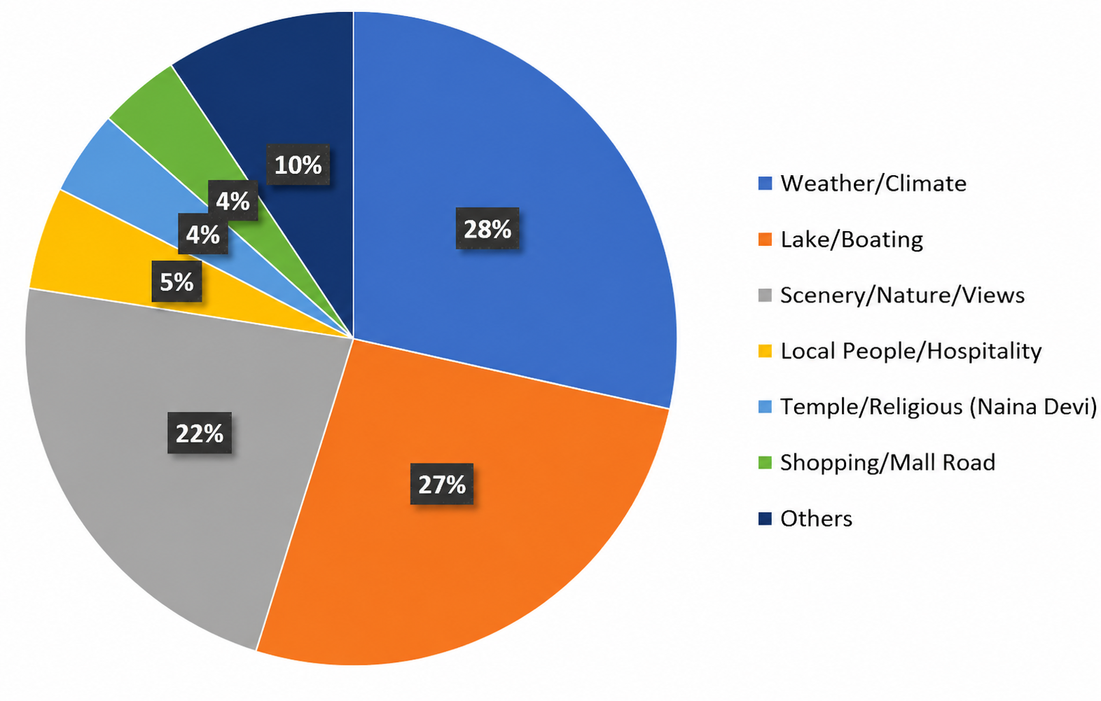
Figure 1: What did you like / best experience? (n = 210 valid responses, 184 had a codeable theme)

The accounts of the challenges tell a story that is complementary. From the 188 valid responses, 92% mentioned at least one specific theme. Traffic and Congestion were cited in 47.9% of the responses and thus constituted by a large margin the biggest challenge. Pricing/Overcharging (28.7%), Overcrowding (17.0%) and Hotel/Accommodation Availability (16.0%) came next. Parking was mentioned in 6.9% of responses, and Local Transport/Cab Issues in 10.1%. When the issues of Traffic, Parking, Local Transport and Roads/Infrastructure are combined into one Mobility and Parking cluster, they make up 60.6% of all the challenge responses, more than twice the size of the next most prominent theme. On the other hand, Cleanliness/Waste (3.7%) and Public Toilets (4.8%) were relatively small concerns.
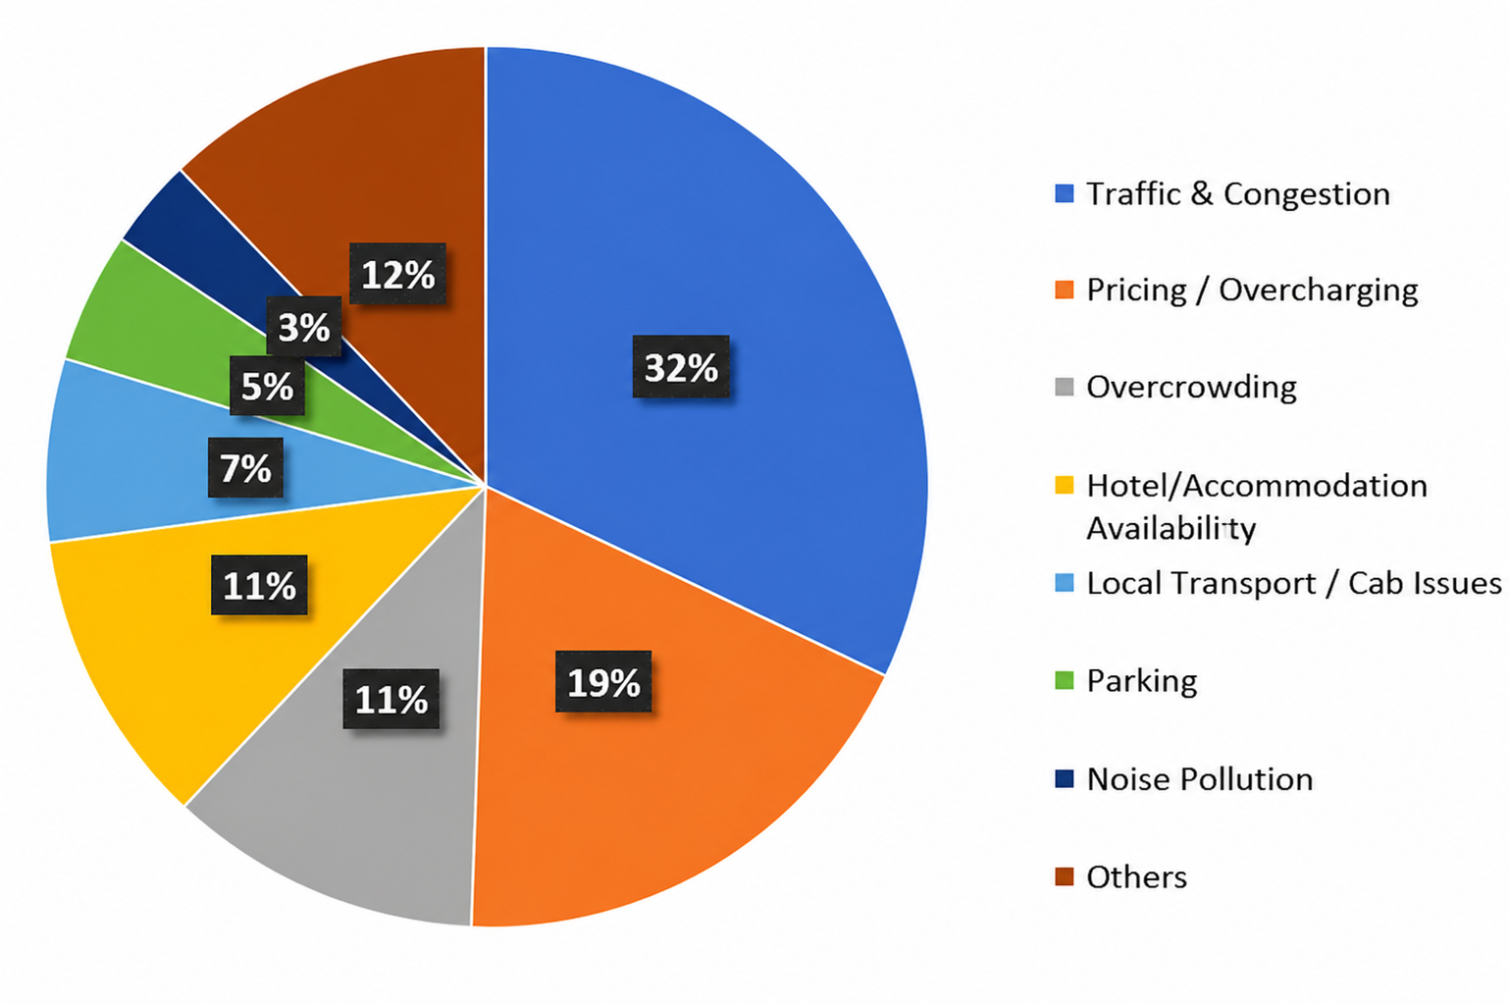
Figure 2: What did you dislike / challenges faced? (n = 188 valid responses, 173 had at least one codeable theme)

When the two questions are considered together, they do not point in different directions; they point in the same direction. Tourists are content with what Nainital essentially is, namely, a lake town with good weather and beautiful scenery, but they are frustrated by the process of getting there, parking near the town, and then moving around it. This is not an instance in which tourists dislike the destination; rather, it is a situation in which the infrastructure is not suited to the volume of traffic and the high number of vehicles arriving as tourists. The demographic pattern supports this: since private vehicles are the main way people reach Nainital, and Delhi and western UP are the primary areas from which tourists come, the group represented in the survey is disproportionately made up of those most likely to encounter traffic and parking restrictions in Nainital.
The takeaway from this report is that the most robust and well-supported evidence concerns mobility and parking, rather than solid waste management. The traffic and congestion theme alone (47.9%) is greater than any other individual theme, and the wider Mobility and Parking category (60.6%) is much larger than the Waste and Cleanliness figure (3.7%). Hence, any policy recommendations based on this dataset should focus first on traffic flow and parking capacity as the main problem, considering overcrowding, pressure on accommodation, and shortages of amenities as related but secondary consequences of the same fundamental limitation.

Policy Recommendations

The survey results make it clear what Nainital's policy makers need to fix first. Six out of every ten complaints tourists made are about traffic and parking, not about litter or dirty toilets, even though those are real problems too. Anyone who has stood in the line of cars near Tallital on a Saturday evening can see this without reading a single statistic. Nainital's real problem is not attracting tourists; it is finding space for them once they arrive. So this section follows the same order as the data points to: mobility and parking first, public amenities second, protecting the environment third and finally the changes in how the town is governed and paid for that will make the other three actually work.

Managing Traffic and Parking at the Source
Nainital simply does not have enough parking for the number of vehicles that come in. On a busy weekend, around 50,000 vehicles enter the town, but there is official parking space for only about 3,000 (Garhwal Post, 2025), and the total legal parking capacity in Nainital is close to 1,070 vehicles (Sharma, 2025). No amount of better signboards or fines can fix a gap that large. The first step, then, is to stop trying to solve parking inside the town and instead manage it before vehicles even get there. An entry permit system, linked to FASTag and a phone app, should be set up at the three main entry points: the Kaladhungi road, the Bhowali junction, and the Haldwani route. This system should show drivers how much parking is actually left at Mallital and Tallital before they enter, and send extra vehicles to parking areas outside the town. This is not a new idea for the region; officials have already talked about FASTag-based prepaid permits and daily vehicle limits, similar to what is used at Kedarnath and Rohtang Pass, so as to bring some order to weekend rushes (Garhwal Post, 2025).
Second, the town needs proper park-and-ride facilities at Bhowali and along the Kaladhungi road, with a shuttle service connecting them to Mall Road, Tallital and the ropeway. This would let tourists leave their cars outside the town instead of driving them into the most crowded and sensitive area. The state's own study of Nainital's carrying capacity, done by the School of Planning and Architecture in Delhi for the Uttarakhand government, has already suggested a stronger bus network between states and within the district to reduce how much tourists rely on private cars (Chitlangia, 2025). The shuttle routes that already exist should run more often, so tourists can actually depend on them instead of treating them as a backup option.
Third, hotels and guesthouses need to be held to proper parking rules, not just asked nicely to follow them. Urban planners who worked on Uttarakhand's hill-town studies have pointed out that states can make it compulsory for hotels to show they have enough parking before they are allowed to register (Chitlangia, 2025). This would stop the current situation where guests end up parking on roadsides and in landslide-risk areas simply because their hotel has no space. New hotel registrations and renewals should require a verified parking plan, with some time given to existing hotels to add or rent nearby parking.
Fourth, the rules Nainital already has, like not allowing vehicles in without a confirmed hotel booking, need to actually be followed every day, not just enforced occasionally after a bad weekend. A checking desk at each entry point, matching incoming vehicles against digital booking confirmations from registered hotels, would make this rule work properly instead of depending on whichever traffic constable happens to be on duty. If a vehicle has no confirmed booking and the outside parking is full, it should simply be turned back at the entry point, not let in to search for space and add to the very traffic the rule was supposed to stop.
Finally, the evening ban on private vehicles that already applies on Mall Road should be extended to run through weekends all year, and paired with different pricing: cheaper entry and parking on weekdays, more expensive on Saturdays, Sundays, and holidays, so that demand spreads out instead of all arriving at once. The Uttarakhand government's new green cess on vehicles from other states, expected to start in December 2025 (PTI, 2024), is a source of money that is already in place for this. A fixed share of the money collected from this cess at Nainital's entry points should be set aside, by policy, specifically for parking and shuttle services in the town, instead of going into the state's general funds.

Strengthening Public Amenities and Accountability
The drop in toilet cleanliness scores from 75 per cent to zero in just one year (Times of India, 2025) is not really about a lack of money; it is about no one being held responsible. Nainital Municipality should hand over the maintenance of toilets and other public facilities at busy spots, the Tallital and Mallital parking areas, Mall Road, and the ropeway base, to private contractors under pay-and-use agreements, with the fees collected going straight back into upkeep. The results of monthly cleanliness checks should also be made public, instead of everyone waiting for the yearly Swachh Survekshan ranking to find out something has gone wrong. If a facility fails two checks in a row, the contractor should face an automatic penalty right away, not a slow process of retendering months later.
Second, the shortage of drinking water in Nainital pushes tourists to buy more bottled water, which only adds to the plastic waste problem (Padmanaaban et al., 2024). This can be fixed directly by setting up water refill points at parking areas, near the ropeway queue, and along Mall Road, using the municipal water supply rather than Naini Lake itself, so the lake is not put under even more pressure during the months when its water level is already at its lowest.
Third, tourists need somewhere to actually get information when they arrive, not just one office somewhere in town. Staffed information kiosks at each entry point and at Tallital should be able to tell visitors, as soon as they get there, where parking is available, when the next shuttle leaves, and where the toilets are. This alone would cut down on the aimless driving around that adds to the traffic.

Protecting Naini Lake and the Environment
Naini Lake's problems go back a long way. Barely half the registered houses in Nainital are connected to a working sewer line, and there is no proper sewage treatment system for the town, so waste from hotels and homes around the lake still flows straight into it (Sengupta et al., 2017). In 2024, the National Green Tribunal divided Nainital into development, regulated, and prohibited zones and directed the state to prepare a plan to treat the lake's catchment area. This gives the government the legal backing it needs, but has not fully used, to expand decentralised sewage treatment and finish the sewer network, especially around Sukhatal, which is the lake's main recharge area. Given that Naini Lake is the town's only source of drinking water, this needs to be treated as urgent, not something to plan for later.
Second, Nainital should gradually restrict single-use plastic bottles in its main tourist areas and bring in a deposit-refund scheme, similar to the one already used at Kedarnath, where visitors pay a small deposit on each bottle and get it back when they return it (Chitlangia, 2025). Sikkim's long experience shows that this kind of restriction can work in a Himalayan tourist economy, as long as it is enforced properly and people have easy alternatives, even if it takes a few years to get everyone on board (UNEP, 2018). Local hotels, tea stalls, and boat operators around the lake should be brought in as partners in making this work, not just told to follow the rules.
Third, the open dumping and burning of solid waste seen around the town needs to be tackled by separating waste at the source, not just collecting and dumping it later. Nainital has actually done this before, through a household composting programme locally known as Mission Butterfly, where kitchen waste was turned into manure at neighbourhood compost pits instead of ending up in the drains that lead to the lake (Sengupta et al., 2017). Bringing this programme back and extending it to hotels, guesthouses, and market areas, which produce most of the waste during tourist season, would keep organic waste out of the 62 drains that flow into Naini Lake and cut down on open dumping and burning. A separate waste collection round timed to hotel checkout hours, when the most waste is generated, would also reduce the temptation to just dump it instead of waiting for the regular round.
Fourth, construction rules in the Sukhatal catchment and other recharge areas need to actually be enforced, not just announced from time to time. The Uttarakhand Tourism Policy 2023 already promises environmentally responsible tourism (Government of Uttarakhand, Department of Tourism, 2023). What is missing is turning that promise into a real ban on construction in marked no-build zones around the lake, checked using satellite monitoring rather than site visits that are easy to get around.

Institutional Coordination and Financing
None of this will work if responsibility for the lake and the town's tourism infrastructure stays split between the municipality, the irrigation department, the Public Works Department, and the Lake Development Authority, with each one blaming the others whenever something goes wrong, which is exactly what has happened for years (Sengupta et al., 2017). Nainital needs one authority with real power over the lake, its catchment area, and tourism infrastructure together, so that there is someone who can actually be held responsible when things do not improve. This matches what the NITI Aayog's hill-area planning framework already recommends: that carrying-capacity studies should come with a clear body to act on them, not just sit as a report on a shelf (Chitlangia, 2025).
Paying for all this does not need a brand-new tax. Between the toll already collected at Nainital's entry points and the state's upcoming green cess on outside vehicles, a dedicated local infrastructure fund, checked every year and reported to the public, could pay for parking, shuttles, and sewage work without adding to the municipality's regular budget. Tourists who come to see the lake deserve to know that some of what they already pay to enter the town is actually being spent on keeping it in good shape.
Finally, none of these steps means much unless someone checks whether they are actually working. The town should not have to wait for the next Swachh Survekshan score or a viral video of traffic on Mall Road to find out that a plan has failed. A short yearly tourist survey, asking the same best-experience and challenges questions used in this brief, would let the municipality see whether complaints about mobility and parking are actually going down as these steps are put in place, instead of just assuming a new permit system or shuttle route is working because it was announced. Since the data clearly shows mobility and parking are the biggest problems right now, that is also where the first year of both action and checking should be focused.

Conclusion

What tourists told us about Nainital is actually a hopeful story, once you look at it closely. People are not tired of Nainital itself. It's the weather, it's a lake, and its views are still exactly why people keep coming back, and almost nobody who answered the survey said anything bad about the destination itself. What frustrates them is everything that happens in between, getting there, finding somewhere to park and moving around once they arrive. That difference matters a lot for policy, because it means Nainital does not need to change what it offers tourists. It needs to fix how tourists reach and move through what it already has.

That is why this brief puts traffic and parking first, ahead of waste and cleanliness, even though those are real problems too. The fall in Nainital's Swachh Survekshan score is a genuine warning sign and should not be ignored. But it is not what most unhappy tourists actually complained about. Far more people were upset about traffic, parking and the roads connecting them than about cleanliness and toilets put together. Putting mobility and parking first, amenities second, and the environment third is not just a personal choice; it is simply what the survey data shows should come first.

At the same time, these problems are not separate from each other, and they are not just a local headache. Every extra car stuck on Mall Road, every hotel built without enough parking, every litre of untreated sewage reaching Naini Lake adds a little more pressure to an area that the National Green Tribunal has already said is being pushed past what it can handle. This is really the same challenge that the United Nations' Sustainable Development Goals ask every town to take seriously: building a liveable, sustainable settlement under Goal 11, keeping water clean under Goal 6, cutting down on plastic waste under Goal 12 and protecting a fragile mountain ecosystem under Goal 15. Nainital does not need to think of these as separate global commitments sitting on a shelf somewhere. Fixing the traffic problem and protecting the lake is, in a very real sense, Nainital doing its part on all four of these goals at once.

None of the ideas in this brief is new or untested. Entry permits, park-and-ride facilities, plastic deposit schemes, and dedicated funding for local infrastructure are already working, at least in some form, elsewhere in Uttarakhand and across the Himalayan region, and they line up with the same sustainable-development thinking that towns everywhere are being asked to follow. What Nainital needs now is not a new idea, but the will to actually put these ideas into practice properly and keep them running, at the scale the town's current number of tourists demands. If that happens, the tourists themselves have already shown, in their own words, that Nainital will still be worth the visit, and worth protecting for the people who call it home.

References

Bhakuni, K. (2017). Issues and challenges of sustainable tourism in Nainital, Uttarakhand. In P. Sharma & S. Rajput (Eds.), Sustainable smart cities in India: Challenges and future perspectives (pp. 383–397). Springer. https://doi.org/10.1007/978-3-319-47145-7_24
Chandra, P., & Kumar, J. (2021). Strategies for developing sustainable tourism business in the Indian Himalayan Region: Insights from Uttarakhand, the Northern Himalayan State of India. Journal of Destination Marketing & Management, 19, 100546. https://doi.org/10.1016/j.jdmm.2020.100546
Chitlangia, R. (2025, January 27). 4 yrs after NGT order, 4 states assess their hill cities to strike a balance between tourism & ecology. ThePrint. https://theprint.in/environment/4-yrs-after-ngt-order-4-states-assess-their-hill-cities-to-strike-balance-between-tourism-ecology/2465064/
Garhwal Post. (2025, June 13). Wake-up call on carrying capacity of tourist destinations in U’khand. Garhwal Post. https://garhwalpost.in/wake-up-call-on-carrying-capacity-of-tourist-destinations-in-ukhand/
Government of Uttarakhand, Department of Tourism. (2023). Uttarakhand tourism policy 2023. https://uttarakhandtourism.gov.in/sites/default/files/2023-06/Tourism-policy-2023.pdf
Hindustan Times. (2025, July 11). Uttarakhand to survey ‘tourist carrying capacity’ in Nainital, Kainchi Dham, Bhowali. Hindustan Times. https://www.hindustantimes.com/cities/others/uttarakhand-to-survey-tourist-carrying-capacity-in-nainital-kainchi-dham-bhowali-101752235535178.html
Indian Express. (2025, April 1). Explained: Why Naini Lake is seeing record-low water levels this year. The Indian Express. https://indianexpress.com/article/explained/explained-why-naini-lake-is-seeing-record-low-water-levels-this-year-9916944/
IARJSET. (2025). Tourism infrastructure readiness in the Indian Himalayan Region: A comparative study of Nainital, Kedarnath and Rudraprayag. International Advanced Research Journal in Science, Engineering and Technology. https://iarjset.com/wp-content/uploads/2025/04/IARJSET.2025.12411.pdf
Padmanaaban, P., Bhattacharya, A., Singh, C. V., & Rustagi, B. (2024). Solid waste management in rural tourism areas in the Himalayas: A case study of Nainital, Uttarakhand. In Solid waste management and disposal practices in rural tourism (pp. 417–440). https://www.researchgate.net/publication/385148626_Solid_Waste_Management_in_Rural_Tourism_Areas_in_the_Himalayas_A_Case_Study_of_Nainital_Uttarakhand
Rastogi, A., & Pant, P. (2023). The impact of tourism with special reference to District Nainital. ShodhKosh: Journal of Visual and Performing Arts, 4(1), 1727–1736. https://doi.org/10.29121/shodhkosh.v4.i1.2023.4471
Sengupta, S., Kukreti, I., & Narain, S. (2017, May 31). Naini Lake is depleting, but can we undo the wrongs? Down To Earth. https://www.downtoearth.org.in/water/revival-of-naini-lake-needs-prompt-action-but-ownership-not-clearly-defined-57979
The Tribune. (2024, December 7). Green cess to be imposed on vehicles entering Uttarakhand; EVs, bikes exempted. The Tribune. https://www.tribuneindia.com/news/uttarakhand/green-cess-to-be-imposed-on-vehicles-entering-uttarakhand-evs-bikes-exempted
Times of India. (2025). Swachh Survekshan: Landour slips amid tourist surge, Nainital still dirtiest cantonment in state. The Times of India. https://timesofindia.indiatimes.com/city/dehradun/swachh-survekshan-landour-slips-amid-tourist-surge-nainital-still-dirtiest-cantonment-in-state/articleshow/122770174.cms
United Nations Environment Programme. (2018, April 26). How the Indian state of Sikkim is working to end plastic pollution. https://www.unep.org/news-and-stories/story/how-indian-state-sikkim-working-end-plastic-pollution

